MATHEMATICS SPECIALIST

MAWA Year 12 Examination 2018

Calculator-free

Marking Key

© MAWA, 2018
Licence Agreement
This examination is Copyright but may be freely used within the school that purchases this licence.
- The items that are contained in this examination are to be used solely in the school for which they are purchased.
- They are not to be shared in any manner with a school which has not purchased their own licence.
- The items and the solutions/marking keys are to be kept confidentially and not copied or made available to anyone who is not a teacher at the school. Teachers may give feedback to students in the form of showing them how the work is marked but students are not to retain a copy of the paper or marking guide until the agreed release date stipulated in the purchasing agreement/licence.

The release date for this exam and marking scheme is
- the end of week 1 of term 4, 2018

Question 1 (5 marks)
Solution
Hence

Also the argument of lies in the fourth quadrant with
Thus for integer so
Hence the four solutions are where and .
Restricting to the given range requires that
where and .

Mathematical behaviours | Marks
- states the correct value for 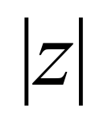  - gives the correct value for  - calculates four distinct solutions of the equation (one mark for 2 or 3)  - restricts the arguments to the appropriate range | 1  1  2  1

Question 2 (a) (4 marks)

Solution
Since

it follows that

Mathematical behaviours | Marks
- identifies correct double angle formula to use  - simplifies the integral to requiring the anti-derivative of  - integrates correctly  - evaluates the indefinite integral at the end points | 1  1  1  1

Question 2(b) (4 marks)

Solution
If we put
then we find that

Mathematical behaviours | Marks
- calculates correctly  - substitutes into integral changing the limits appropriately  - integrates the expression correctly  - substitutes the boundary values and simplifies to a suitable form | 1  1  1  1

Question 2 (c) (4 marks)

Solution
If we put then and the integral
Hence if the integral equals we conclude that

Mathematical behaviours | Marks
- identifies that  - identifies the most appropriate substitution  - evaluates the integral correctly and thereby  - deduces the correct value of | 1  1  1  1

Question 3 (a) (2 marks)
Solution
Mathematical behaviours | Marks
- matches one graph correctly  - matches a second graph correctly | 1  1

Question 3 (b)(i) (3 marks)
Solution
Mathematical behaviours | Marks
- uses implicit differentiation to determine  - calculates and at  - correct conclusion | 1  1  1

Question 3 (b)(ii) (4 marks)
Solution
Mathematical behaviours | Marks
- separates the variables  - determines the correct anti-derivaties  - calculates the constant correctly  - states the required particular solution | 1  1  1  1

Question 4 (a) (3 marks)
Solution
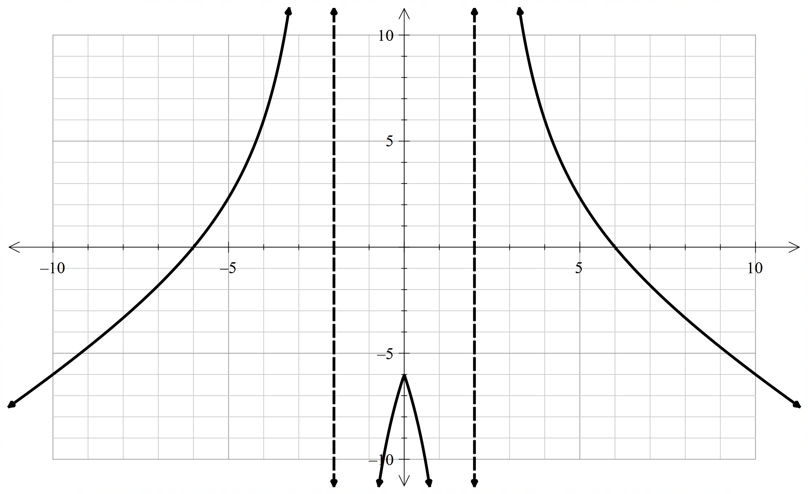
Mathematical behaviours | Marks
- draws both vertical asymptotes  - draws correct graph for  - draws correct graph for | 1  1  1

Question 4 (b) (3 marks)
Solution
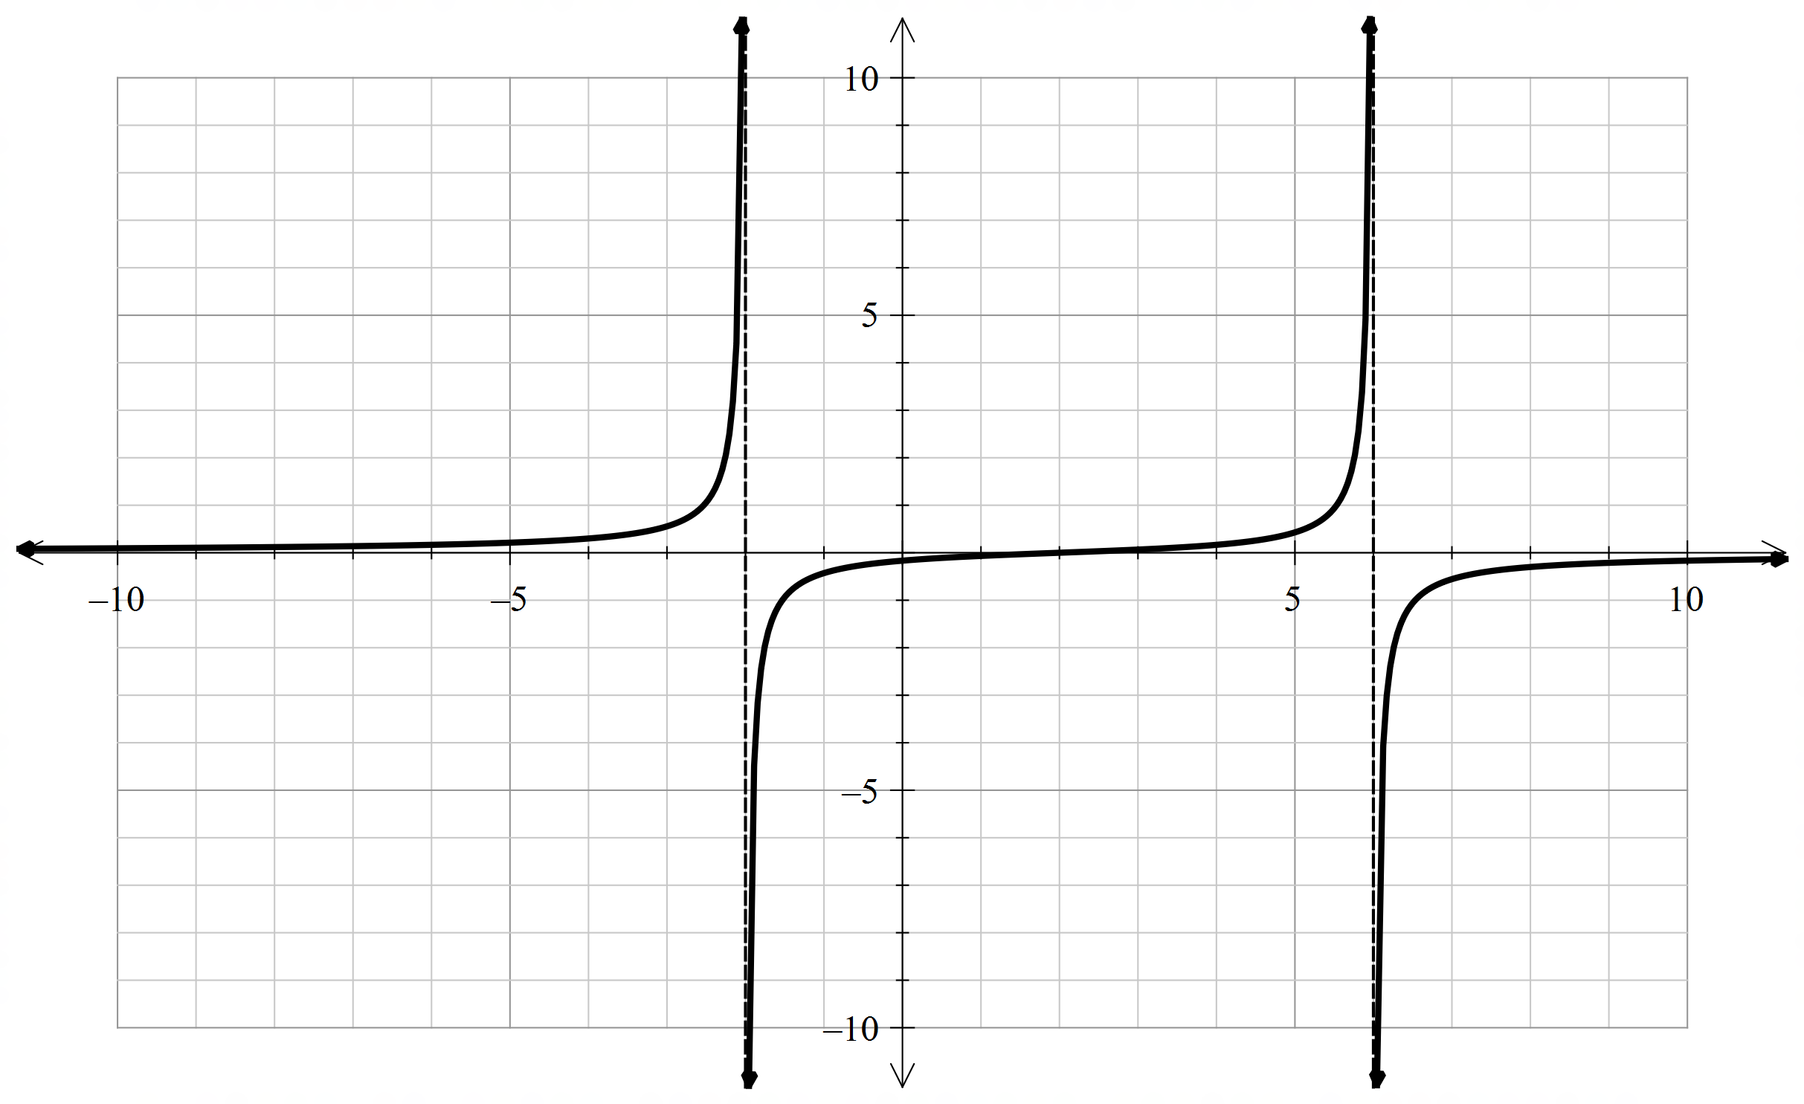
Mathematical behaviours | Marks
- draws vertical asymptotes at and at  - draws correct graph for  - draws correct graph for and for | 1  1  1

Question 5 (a) (2 marks)

Solution
The equation $x^{2}+y^{2}+z^{2}-8x+12y-24z+171=0$ can be rewritten as

${(x-4)}^{2}+{(y+6)}^{2}+{(z-12)}^{2}=4^{2}+6^{2}+{12}^{2}-171=25$ (*)

So the centre C has coordinates $\left(4,-6,12\right)$ and the radius is $\sqrt{25}=5$

Mathematical behaviours | Marks
- obtains co-ordinates of C  - calculates radius correctly | 1  1

Question 5 (b) (3 marks)

Solution
The point A lies on the line segment $\vec{OC}$ and on the sphere S.

So A has coordinates $\left(4t,-6t,12t\right)$ for some $t$

Substituting into the equation for S gives

${(4t-4)}^{2}+{(-6t+6)}^{2}+{(12t-12)}^{2}=25$

i.e. $196{(t-1)}^{2}=25.$ i.e. $t-1=±5/14$

$t=9/14$ gives the point closest to O, so the coordinates of A are .

Alternative method:
Distance of the centre of the sphere from the origin is
Radius of sphere is so required point is along the line joining O to
Hence the point A is as before
Mathematical behaviours | Marks
- obtains the correct form of the co-ordinates A in terms of a parameter  - solves for the parameter  - derives the appropriate co-ordinates of A  ALTERNATIVE  - determines distance of centre from origin  - determines required point is 9/14ths along the line OC  - derives the appropriate co-ordinates of A | 1  1  1  1  1  1

Question 5 (c) (3 marks)

Solution
The vector $\vec{OA}=2i-3j+6k$ is normal to P.
So $2x-3y+6z=c$ (*) is a Cartesian equation of P.
Since A lies on P,
So $2x-3y+6z=63$is a Cartesian equation of P.

Mathematical behaviours | Marks
- recognises the normal to the plane  - writes down the correct form of the equation of the plane (*)  - evaluates the constant correctly | 1  1  1

Question 6 (a) (2 marks)

Solution
False

The confidence interval may contain NONE of the original population.
For example, if the population consists just of 0’s and 1’s, and the sample size is large enough, then
$$0<\overline{X}-E<\overline{X}+E<1.$$

Mathematical behaviours | Marks
- states correct answer  - gives a valid reason | 1  1

Question 6 (b) (2 marks)

Solution
True

The probability that any one confidence interval will contain the mean is equal to the confidence level, i.e. 90% or 0.9
Mathematical behaviours | Marks
- states correct answer  - gives a valid reason | 1  1

Question 6 (c) (2 marks)

Solution
False

Because the samples are independent and random it is possible that NONE of the confidence intervals will contain $μ$

Mathematical behaviours | Marks
- states correct answer  - gives a valid reason | 1  1

Question 6 (d) (3 marks)

Solution
True

The probability that exactly 9 of the 10 confidence intervals will contain $μ$is
$B\left(10,9,0.9\right)=\left(\begin{matrix}10 \\ 9\end{matrix}\right)×{0.9}^{9}{×0.1}^{1}=10×{0.9}^{9}×0.1={0.9}^{9}$(*)
On the other hand, the probability that all of the 10 confidence intervals will contain $μ$is $B\left(10,10,0.9\right)={0.9}^{10}.$ (**)
Clearly ${0.9}^{9}>{0.9}^{10}.$

Mathematical behaviours | Marks
- states correct answer  - derives the correct expressions (*) and (**) for the respective probabilities | 1  1+1

Question 7 (5 marks)

Solution
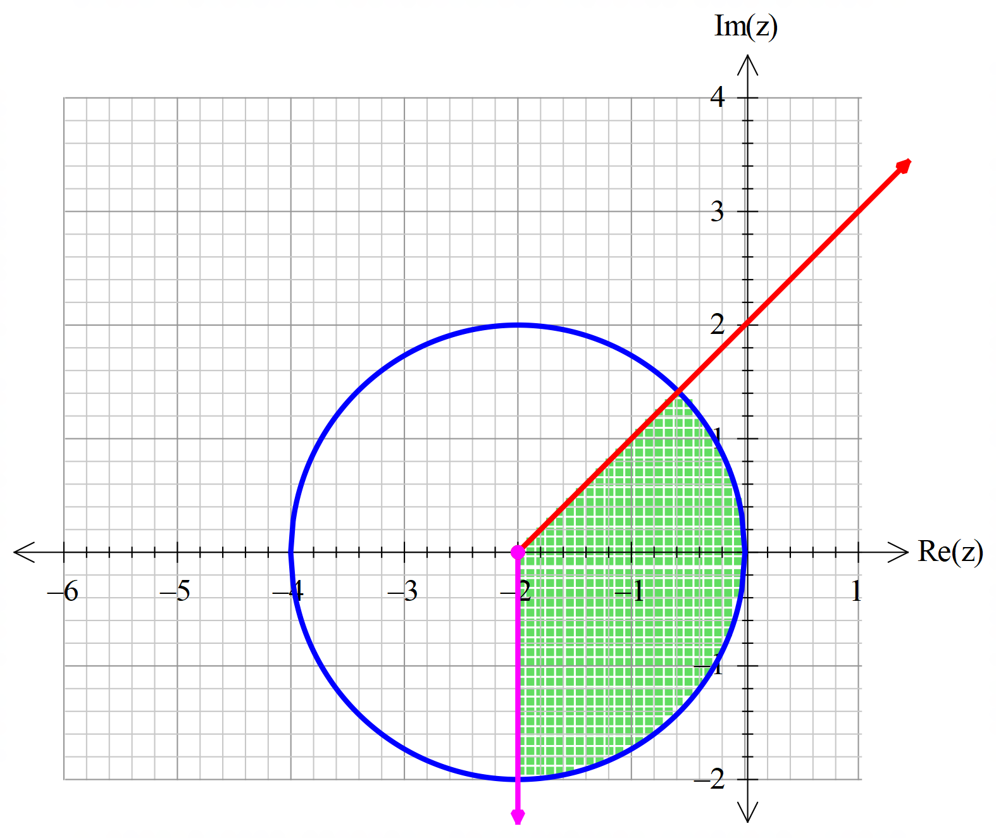

Mathematical behaviours | Marks
- shows circle with correct centre and radius  - shows correct wedge with the correct angles  - shades required area indicating that boundaries should be included | 1+1  1  1+1

